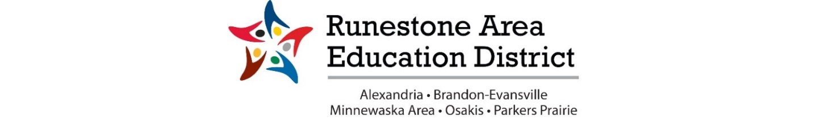

RAED Superintendent Members
2022-2023 School Year

ALEXANDRIA PUBLIC SCHOOL RICK SANSTED WORK: 320-762-2141
P.O. BOX 308
ALEXANDIA, MN 56308
rstansted@alexschools.org

BRANDON-EVANSVILLE PUBLIC SCHOOL LOUISA GLENETSKE WORK: 320-834-4084
P.O. BOX 185
BRANDON, MN 56315
lglenetske@b-e.k12.mn.us

MINNEWASKA AREA SCHOOLS CHIP RANKIN WORK: 320-239-4820
25122 STATE HIGHWAY 28
GLENWOOD, MN 56334
crankin@isd2149.org

OSAKIS PUBLIC SCHOOL RANDY BERGQUIST WORK: 320-859-2191
P.O. BOX X
OSAKIS, MN 56360
rbergquist@osakis.k12.mn.us

PARKERS PRAIRIE SCHOOL PETER HAAPALA WORK: 218-338-6011
411 SOUTH OTTER AVE., BOX 46
PARKERS PRAIRIE, MN 56361
phaapala@pp.k12.mn.us

